**BubbleRunner GDD**



**Edu Giménez Pino**

**Ferran Cantariño i Iglesias**

**INDEX**

1. About us
2. Product description
   1. Concept
   2. Target player
   3. Platform & Tools
   4. References
3. Game
   1. Obstacle Types
   2. GameOver Condition
   3. Distinctive Mechanic
   4. Core Game Loop
   5. Retention
4. Monetization

**1. About us**

We are two university students who share their passion for video games. One of us is studying the Interactive Digital Contents Degree at ENTI (School of New Interactive Technologies). The other one is studying Informatic Engineering at UPF (Pompeu Fabra University). We intend to develop indie video games and this is our first project together.

**2. Product description**

2.1. Concept

BubbleRunner is a 3D runner video game where the player controls a character that can move sideways on 3 different lanes and jump (see figure below).

The objective is to avoid obstacles while moving forward in an infinite rail.

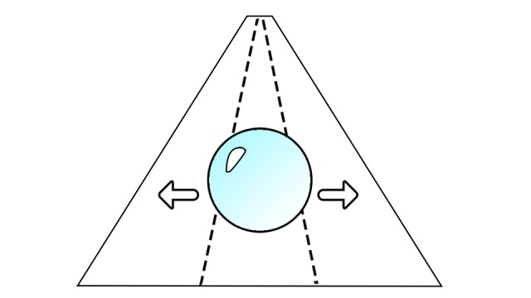

2.2. Target

The age of the target player ranges between 5 and 25 years old and is a casual gamer.

2.3. Platform & Tools

The game has been designed for smartphones and tablets.

The engine is Unity 3D (5.1.3f1) and the graphic modeling program is 3D Max (2015).

2.4. References

Subway Surfers, Temple Run...

**3. Game**

In Bubble Runner, the player controls a bubble which is able to move sideways on 3 different lanes and to jump. This will allow the bubble avoid the obstacles that it will face frontally while it moves forward in an infinite rail while achieving distance ranking.

3.1. Obstacle Types

* *Normal*: this is an obstacle which stops you from moving beyond where it is located.
* *Rebound*:when hit laterally, this obstacle bounces you off the opposite direction. When hit frontally, it behaves like a normal obstacle.
* *Explote*: when this obstacle is hit, the game is over.

3.2. GameOver Condition

* Get out sideways of the three different lanes.
* Hit an *Explote Obstacle*.
* Hit a *Normal* or a *Rebound Obstacle* frontally so it stops you from moving forward.

3.3. Distinctive Mechanic

The character has an extra feature: it can be split. This represents a new game mode in which the player has to control two bubbles with both hands (one bubble per hand).

This mode will appear randomly in the game.

3.4. Core Game Loop

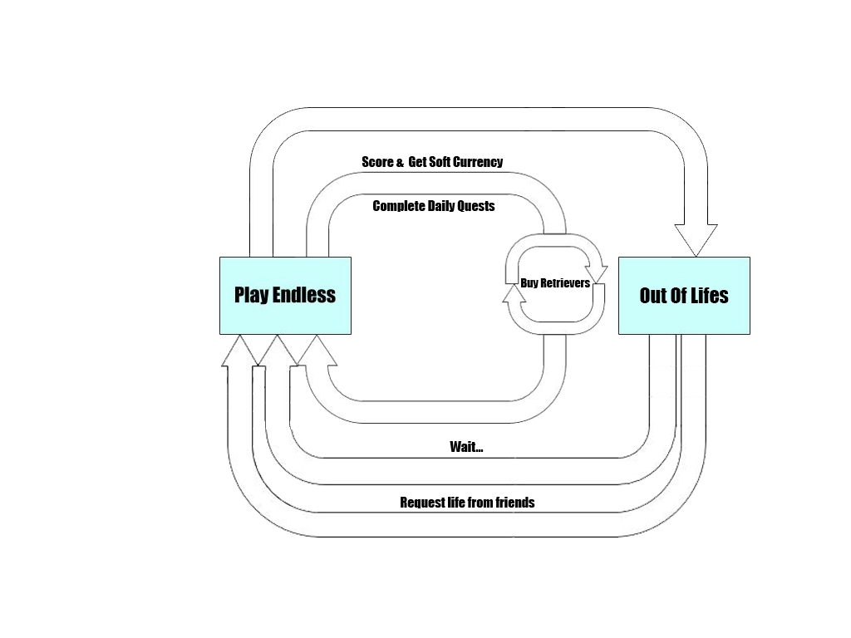

The user may play whilst having life. When running out, he can wait until achieving more or request it from friends via social networks.

By increasing the score, earning coins and completing quests the player may buy retrievers to have a second chance to play when he dies.

3.5. Retention

BubbleRunner works with an energy based system (lives) that will be lost as the player loses in the game. This way, the session won’t be too long (letting the user play in any moment he/she has) and, as the recharge is fast, he/she will be able to try again in short time.

In addition, everyday will have the motivation to play for completing the daily quests. During the day will be checking if the lives are charged in order to finish them, because it will be difficult to completing all in one single session.

**4. Monetitzation**

The user may play while having life. One life is subtracted when dying.

Lifes are regenerated after a while or, in case the player does not wish to wait, he can invite his friends through social networks to earn them quicker.

While the user plays, he may earn coins (soft currency) by two different means: collecting them or completing daily quests.

The user may use these coins to buy retrievers when he dies. He will get a discount if he buys them in packs with hard currency. Besides, coins may also be used to obtain alternative graphic background of the game (a bathtub, a river, the sea, the sewage system, waterfalls, etc.) at a high rate (soft currency) or at an affordable real price (hard currency).